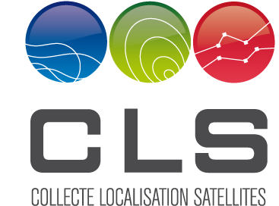

ARGOS

***TUTORIAL***

|  |  |  |
| --- | --- | --- |
| Subject: | Argos Web Service Client Generation with PHP | |
| Reference: | CLS-DIR-MEMO-2012-184 | **From:** |
| Nomenclature: | ARG-MO-22-1478-CLS | M. Turiot |
| Issue: | 1. 0 | **To:** |
| Date: | 07/03/2012 | Argos Web Service Users |
|  |  | **CC:** |
|  |  | CLS TSU |

**List of content :**

1. Caution 2

2. Prerequisites 2

2.1. System Configuration 2

2.2. WampServer 2

2.3. WSO2 WSF PHP 2

3. Create Argos Web Service Client 2

3.1. Start and configure the server 2

3.2. Create your application code 3

3.3. Execute your application code 4

3.4. Use getXml service 6

3.5. Use getStreamXml service 7

# Caution

This tutorial is an example of a client generation, from scratch, for the Argos Web Service.

It has been elaborated on a particular configuration (Windows XP pro SP3, 32bits).

CLS does not constrain the user to a specific configuration.

CLS does not guarantee that this tutorial works on another configuration.

CLS provides this material “as is” and makes no warranty of any kind, expressed or implied, including, but not limited to, the implied warranties of merchantability and fitness for a particular purpose. CLS shall not be liable for errors contained herein or for incidental or consequential damages (including lost profits in connection with the furnishing, performance or use of this material, whether based on warranty, contract, or other legal theory).

This document could include technical inaccuracies or typographical errors. Changes are periodically made to the information herein; these changes will be incorporated in new editions of the tutorial. CLS may make improvements and/or changes in the product(s) and/or program(s) described in this tutorial at any time.

# Prerequisites

## System Configuration

A Personal Computer with Windows XP professional has been used in this tutorial.

For a PHP tutorial in French, look at <http://sylvie-vauthier.developpez.com/tutoriels/php/grand-debutant/>

## WampServer

The php server used in this tutorial is Wamp Server 2.

Download it from the official site [http://www.wampserver.com/](http://www.wampserver.com/" \o "télécharger WampServer) and install it.

## WSO2 WSF PHP

There is no support for MTOM or SWA (Soap with Attachment) in PHP SOAP. [WSO2 WSF/PHP](http://wso2.org/projects/wsf/php) supports sending binary attachments with SOAP messages with SOAP MTOM implementation.

See also <http://en.wikipedia.org/wiki/List_of_web_service_frameworks>

Download wso2 from: <http://dist.wso2.org/products/wsf/php/2.1.0/wso2-wsf-php-bin-2.1.0-win32.zip>

Install WSO2 WSF PHP binary in WampServer. Look at: <https://wso2.org/wiki/display/wsfphp/Installing+WSO2+WSF+PHP+Binary+in+WampServer>

# Create Argos Web Service Client

## Start and configure the server

Look at <http://www.wampserver.com/presentation.php>

Start WampServer.

When you installed WampServer, a directory named “www” has been automatically created (typically in c:\wamp\www).

Create a subdirectory for your project to put your php files into it

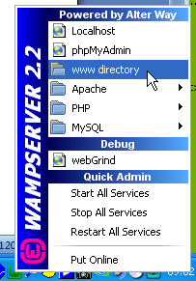

If the server does not start, the server icon in windows application bar remains orange. You have to check if another service uses port 80, and deactivate it. See the following information:

**Re: Bad Request (Invalid Hostname)**

Posted by: [mrudul](http://forum.wampserver.com/profile.php?2,20509) (---.80.170.122.airtelbroadband.in)

Date: October 16, 2011 10:01AM

1.First I checked which application is using Port 80 through WAMP->Apache->Service->Test Port 80.   
2. Found that Microsoft HTTPAPI/2.1 is using port 80 on my machine   
3. Checked the [griffith.wordpress.com] and found that Web Development Agent Service is running on the machine. [ I am using Windows XP and other users too can find a solution with different Windows version.   
4. I disabled "Web Development Agent Service" through Control Panel/Administrative Tools/Services   
[You can check the service running on your port 80 and then act accordingly]   
5. Started Apache Server   
6. Tested Port 80



## Create your application code

Put your php files into your application subdirectory.

Example : [argos-soap-test.php](http://localhost/Argos/argos-soap-test.php).

Cet exemple appelle la méthode getXml du serveur et affiche le résultat.

This example calls the getXml service and displays the result :

<?php

// Request parameters

$param = array(

'username'=>'mtttttt',

'password'=>'xxxxxxxx',

'platformId'=>'123456',

'nbDaysFromNow'=>'1'

);

try {

// WebService Client options and configuration

$options = array(

'useSOAP'=>1.2,

'useMTOM'=>TRUE,

'responseXOP'=>FALSE,

'wsdl'=>'http://ws-argos.cls.fr/argosDws/services/DixService?WSDL'

);

$client = new WSClient($options);

$proxy = $client->getProxy();

// Call the service

$results = $proxy->getXml($param);

// Get and display the response

$xml = $results["return"];

echo htmlentities($xml);

echo '<br>';

// Call the service

$results = $proxy->getCsv($param);

// Get and display the response

$csv = $results["return"];

echo $csv;

echo '<br>';

// end

} catch (Exception $e) {

echo "<h2>Exception Caught</h2>";

echo $e->getMessage();

}

?>

## Execute your application code

Click in the menu "Localhost" of WampServer, or open your favorite web explorer.

Go to the http://localhost address.

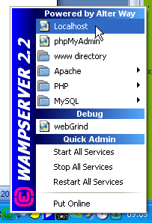

The following page shall appear in your web browser

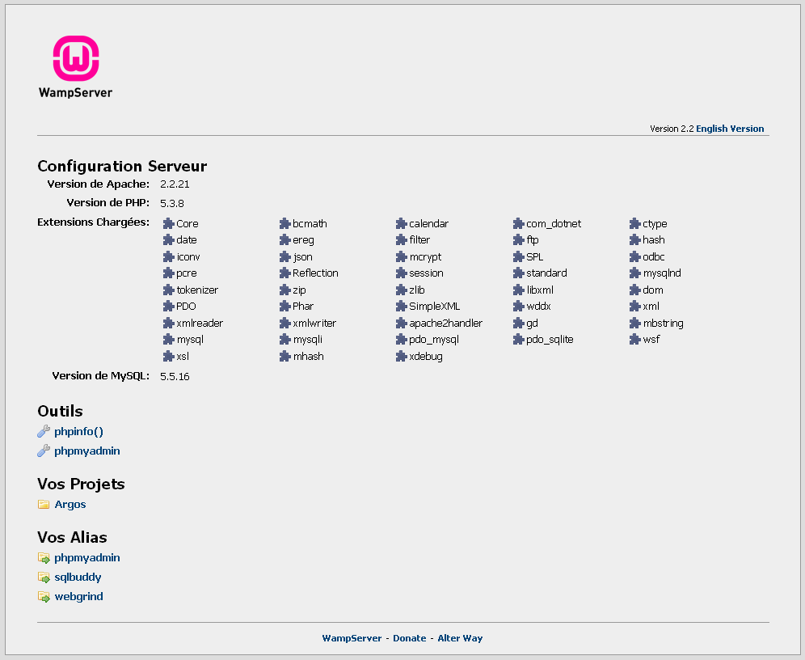

Click on Argos project.

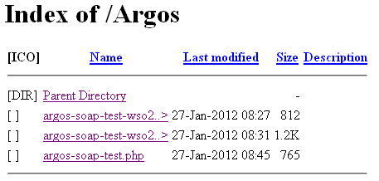

To execute the code, click [argos-soap-test.php](http://localhost/Argos/argos-soap-test.php)

The expected result is shown below :

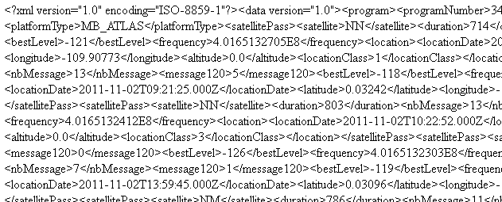

## Use getXml service

The following sample code displays getXml response:

<?php

$param = array(

'username'=>'tttttt',

'password'=>'xxxxxx',

'platformId'=>'123456',

'nbDaysFromNow'=>'1'

);

try {

// WebService Client options

$options = array(

'useSOAP'=>SOAP_1_2,

'useMTOM'=>TRUE,

'responseXOP'=>FALSE,

'wsdl'=>'http://ws-argos.cls.fr/argosDws/services/DixService?WSDL'

);

$client = new WSClient($options);

$proxy = $client->getProxy();

// Call the service

$results = $proxy->getXml($param);

// Get and display the response

$xml = $results["return"];

echo htmlentities($xml);

echo '<br>';

// Call the service

$results = $proxy->getXsd();

// Get and display the response

$xml = $results["return"];

echo htmlentities($xml);

echo '<br>';

// end

} catch (Exception $e) {

echo "<h2>Exception Caught</h2>";

echo $e->getMessage();

}

?>

## Use getStreamXml service

Use the same method to use getStreamXml service

<?php

$param = array(

'username'=>'tttttt',

'password'=>'xxxxxx',

'platformId'=>'123456',

'nbDaysFromNow'=>'1'

);

try {

// WebService Client options

$options = array(

'useSOAP'=>1.2,

'useMTOM'=>TRUE,

'responseXOP'=>TRUE,

'wsdl'=>'http://ws-argos.cls.fr/argosDws/services/DixService?WSDL'

);

$client = new WSClient($options);

$proxy = $client->getProxy();

// Call the service

$results = $proxy->getStreamXml($param);

// Get and display the response

$xml = $results["return"];

echo htmlentities($xml);

// end

} catch (Exception $e) {

echo "<h2>Exception Caught</h2>";

echo $e->getMessage();

}

?>